**NASA Asteroid Data Analysis**

**CS 5525 Cloud Computing Project**

**Team Members:**

Sindhusha Tiyyagura

Pradeepika Kolluru

**Main Objective:**

The main objective of our project is to analyse NASA Asteroid space data and to display the data in more sophisticated ways such as dashboards, space view along with objects, line graphs, and bar graphs.

**Motivation:**

A data analysis and visualization graph helps to

1) Find out data patterns

2) Predict the impact of future object based on their size and velocity.

3) Can understand the data properly

4) Figure data outliers

**Block Diagram:**

**Architecture:**

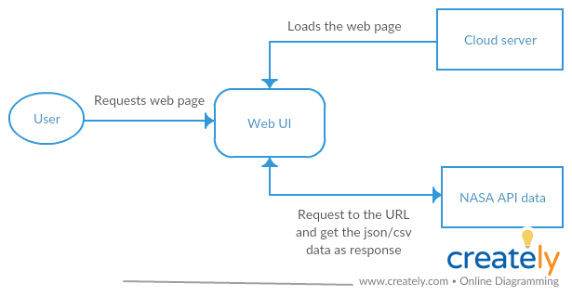

**Technologies Used:**

Angular 7 for creating web application

Python and PyCharm for data collecting, cleaning, visualization

Real-time data from NASA Asteroid API

Open source visualisation tools

GitHub for tracking source code

**Type of project:**

Visualisation and Development

**NASA Asteroid API: (Data Analysis)**

NeoWs (Near Earth Object Web Service) is a web service for near earth Asteroid information. With NeoWs a user can

1) Search for Asteroids based on their closest approach date to Earth

2) Lookup a specific Asteroid with its NASA JPL small body id, as well as browse the overall data-set.

**Data-set:** All the data is from the NASA JPL Asteroid team (<http://neo.jpl.nasa.gov/>).

The data set gives the following data about the asteroid:

1) Size of the object. 🡪 Diameter ( in meters )

2) Velocity (speed) of the object. 🡪 Velocity ( in km/s)

3) Orbital data of the object (journey/path of the object).

4) Miss distance of the object to the earth. 🡪 Close Approach Distance (CA) either in Lunar Distance or au(astronomical unit)

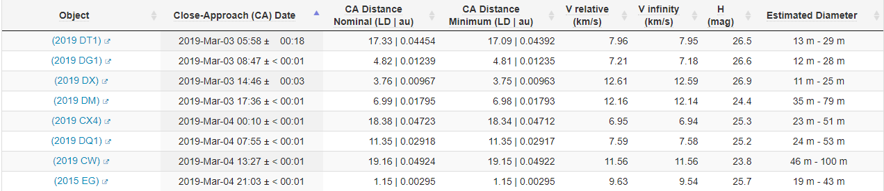

**Visualization of data:**

1) Based on the selection of asteroid, user can see the orbit path(animation) of the asteroid around the earth.

2) Showing dashboard with list of top Biggest, Fastest, Closest, Dangerous objects to the earth.

3) Number of Objects discovered for a given time period range.

4) Other comparisons on asteroids like

Size Vs velocity 🡪 can categorize into range where most of objects fall into.

Distance to earth Vs Size 🡪 can identify closest approaching object

**Future Work:**

1) Predict the orbital path of the asteroid with respective to the earth.

2) Predict the probability of impact of object on the earth.

**Learning:**

How to analyse, clean and split data?

How to display the data to users? (In more understandable format)

Using visualization tools

Python and angular for developing web pages and processing data.